Calendar Use Case

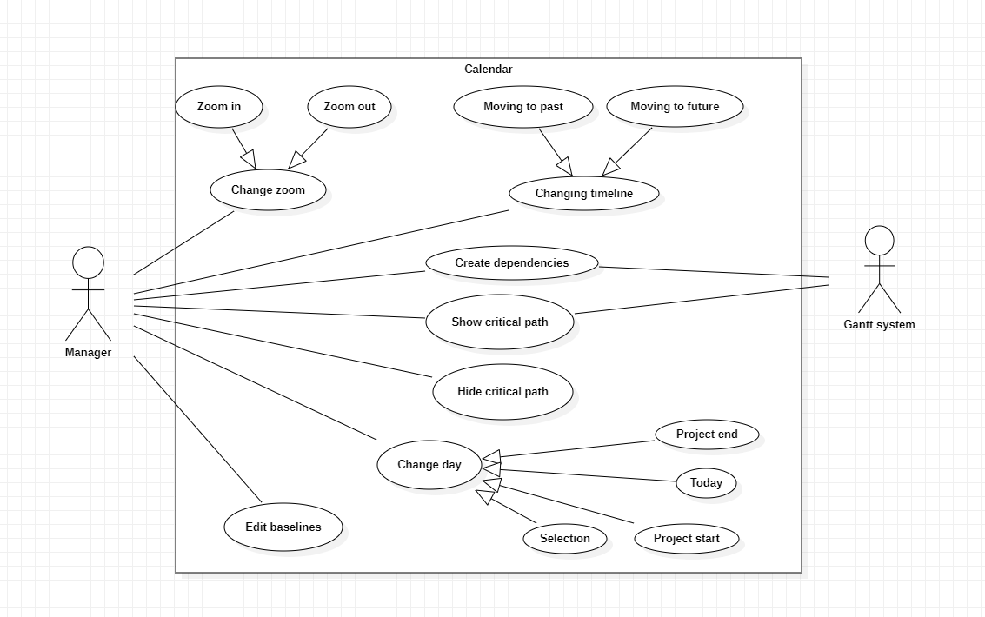

Edit baselines

Pre-condition: None

This functionality changes the size and color of the baselines.

Primary Actor:

* Manager.

Secondary Actor:

* None.

Change day

This functionality will let u change the specific date the calendar is displaying.

Primary Actor:

* Manager.

Secondary Actor:

* None.

Project end

Pre-condition: None.

This functionality shows the calendar where the project has ended.

Primary Actor:

* Manager.

Secondary Actor:

* None.

Today

Pre-condition: None.

This functionality shows the calendar in the present day.

Primary Actor:

* Manager.

Secondary Actor:

* None.

Project Start

Pre-condition: None.

This functionality shows the calendar where the project has started.

Primary Actor:

* Manager.

Secondary Actor:

* None.

Selection

Pre-condition: None.

This functionality shows the calendar where the selected task is.

Primary Actor:

* Manager.

Secondary Actor:

* None.

Show critical path

Pre-condition: Critical path is not shown.

This functionality shows the critical path of our tasks using the Gantt system.

Primary Actor:

* Manager.

Secondary Actor:

* Gantt system.

Hide critical path

Pre-condition: None

This functionality shows the critical path of our tasks

Primary Actor:

* Manager.

Secondary Actor:

* None.

Create dependencies

Pre-condition: There needs to be at least 2 tasks to make a dependency.

Add resource allow the manager to specify who should do the task.

Primary Actor:

* Manager.

Secondary Actor:

* Gantt System.

Change timeline

This functionality lets u go more to the future or the past.

Primary Actor:

* Manager.

Secondary Actor:

* None.

Moving to past

Pre-condition: None.

This functionality lets u go to the past in the calendar.

Primary Actor:

* Manager.

Secondary Actor:

* None.

Moving to past

Pre-condition: None.

This functionality lets u go to the future in the calendar.

Primary Actor:

* Manager.

Secondary Actor:

* None.

Change zoom

This functionality makes the calendar be further away or closer.

Primary Actor:

* Manager.

Secondary Actor:

* None.

Zoom in

Pre-condition: None.

This functionality makes the calendar closer so u can see in more detail the days.

Primary Actor:

* Manager.

Secondary Actor:

* None.

Zoom out

Pre-condition: None.

This functionality makes the calendar father so u can see the full picture better.

Primary Actor:

* Manager.

Secondary Actor:

* None.